Dental Implant Treatment Proposal for:
Patient name

Prepared by: Dentist Name
Date

Patient Name
Patient Address

Dear Patient Name,

Dental Treatment

It was a pleasure meeting you recently at FAME Dentistry to discuss your concerns and treatment goals. This letter summarises our conversation, outlines the treatment options available, and provides a provisional treatment plan with estimated costs for your care.
Patient friendly explanation of clinical notes.
Clinical assessment explained in patient friendly words.
OPT with area marked for patient reference.
Medical History
There were no medical contraindications to possible implant treatment.
Allergies
There is some evidence to suggest that vitamin D deficiency can lead to early failure of implants. Therefore, in most cases we suggest that you consider a healthy diet and if necessary, regularly take Vitamin D and C supplements and Calcium to support your bone healing throughout the course of the treatment.

There are various treatment options available to you to replace any missing teeth, and we discussed these in detail, but I would just like to remind you of them.

No Treatment
Accept the spaces in your mouth. This is a possibility although your concerns would not be rectified. I do not see this as a real option but it is always considered.

Dentures

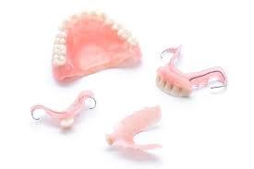
This is the most straightforward and basic treatment available which involves the construction of either acrylic (plastic) or chrome (metal) permanent dentures, which must be removed several times a day for good oral hygiene.
You told me you did not want to have a permanent denture and prefer a fixed option if possible.

Conventional Bridge
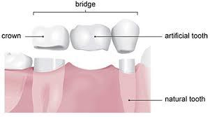
This is the preparation of the teeth either side of the space to allow the attachment of a bridge tooth to these adjacent teeth. This is a widely practised, and often successful method of replacing missing teeth. It has the disadvantage that it can sometimes weaken the supporting teeth, if extensive preparation is needed. The bridge supporting teeth can have an increased susceptibility to decay, fracture or nerve de-vitalisation (this is when the nerve inside the tooth dies and requires root canal treatment). Studies show that this risk is between 5-18%.

Dental Implants
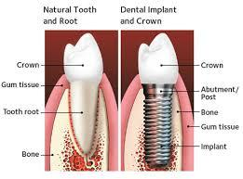
This is the placement of a small titanium screw (implant) in the jawbone under the gum. The implant can then be used to secure a crown as a permanent restoration for your missing tooth.

This information is to help you make an informed decision about having implant treatment. You should take as much time as you wish to make the decision in relation to signing the following consent form. You are encouraged to ask any questions and have these answered to your satisfaction before you give permission for the treatment to be carried out.

Below is described your proposed dental implant treatment and the formal terms and conditions of my engagement. I apologise for the large amount of information contained in this letter but it is important that you should understand and read it carefully. Please keep this letter in a safe place as the treatment described is long-term and it can often be difficult to remember the exact details several months later. If you are unclear as to any of the areas discussed please contact me.

It is important at all times to remember that dental implant treatment is complicated dentistry involving surgery and complex restorative procedures. While every effort is made to provide your treatment to the highest possible standard, using highly trained individuals, it is inevitable that in a small number of cases complications will still occur. These complications can be surgical or restorative in nature and may require treatment by third parties in other environments if complications are significant. At all times the clinicians and staff at Edinburgh Dental will put your welfare first and ensure that complications are treated to the best of our ability and as quickly as possible. If you feel unable to accept the fact that complications may occur despite the best efforts being undertaken by all members of your caring team it may be worthwhile discussing further options for your treatment or postponing treatment entirely until you feel happy to accept the small risks that do exist.

During the course of the implant treatment, it is important that you keep me informed of any changes to your general medical condition (including medication) and of any other additional treatment you may be receiving from a doctor or dentist. Failure to do so may adversely affect or delay your treatment.

It is also important that you keep your appointments and do not miss any stages, as this could adversely affect treatment and delay placement of the new teeth.

Once you have read and understood the information below, please sign, date and initial the individual areas of your plan.

Any changes to the treatment plan detailed below would obviously be discussed with you and amendments made where necessary prior to treatment being undertaken.
Your treatment would be carried out as follows:
Executive Summary for implant treatment
Restoration of Area

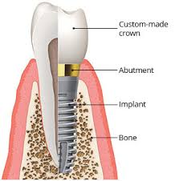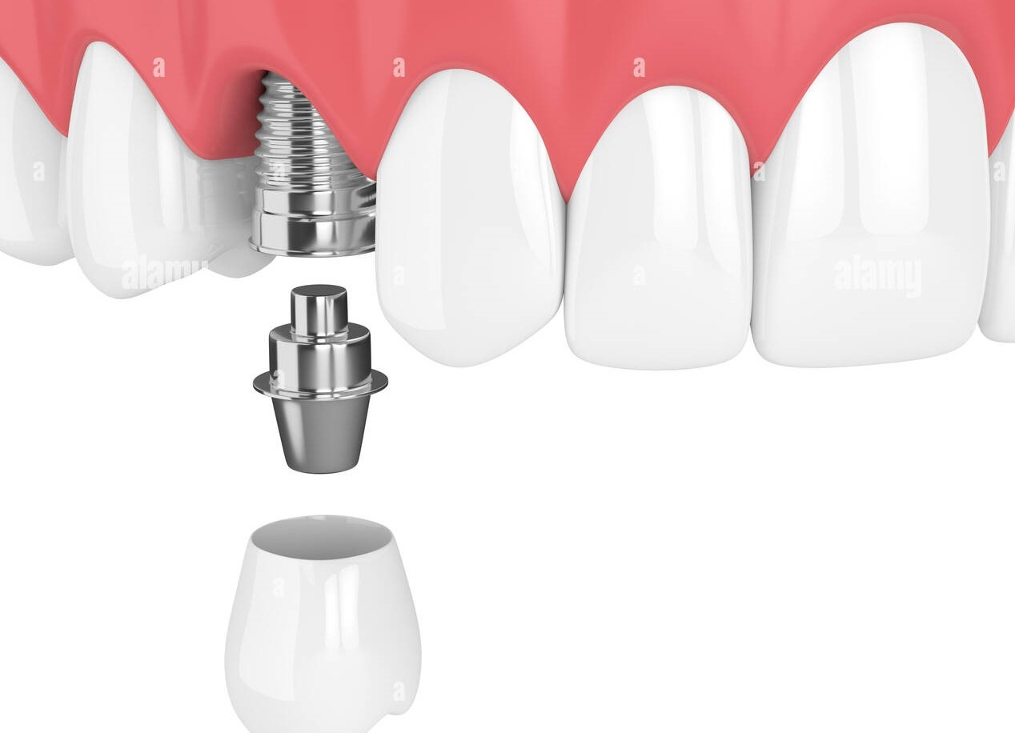
Implant Structure Implant Retained Crown
Total cost of treatment if full plan undertaken: Amount
Estimated time for treatment completion (this may be variable depending on the success of how treatment progresses): Duration
Your designated point of contact within the practice for queries is: Pratibha Singh who can be contacted via email: info@edinburghdental.co.uk

-Appointment 1

Appointment explained.

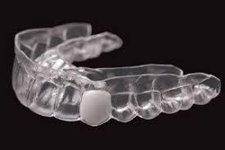
Essix Retainer

Total Cost of Appointment 1 Cost

-Appointment 2

Approximately 2-3 weeks after the procedure, we will see you again to assess healing and remove any remaining sutures if necessary.

Total Cost of Appointment 2 Cost

-Appointment 3

Approximately 3-4 months after the procedure, we will book you in for a CBCT (3D) scan to assess bone health and suitability for implant placement.

We will also take an intra oral (3D) scan to construct surgical guide for precision placement of implants.

Total Cost of Appointment 3 Cost

-Appointment 4

As discussed, we will book you in for placement of implants in the upper left premolar area using a surgical guide for precision placement.

Implants usually need to be allowed to heal undisturbed for 3-4 months to fully Osseo-integrate or heal with the bone.

Total Cost of Appointment 4 Cost

-Appointment 5

Approximately 2-3 weeks after the surgery, we will see you again to assess healing and remove any remaining sutures if necessary.

Total Cost of Appointment 5 Cost

-Appointment 6(carried out approximately 3 months after the implant is placed)

A second, much quicker and less invasive, surgery will be undertaken to expose your implant. Healing abutments will be placed to encourage the soft part of your gum to heal around the neck of your implant.
The gum needs to heal for 2-3 weeks before an impression can be taken.

Total Cost of Appointment 6 Cost

-Appointment 7

An impression or intra oral scan will be taken of your implants and healed gum tissue so that your implants can be custom made by our dental laboratory. The final crowns are usually ready to fit at least 2 weeks after the impressions are taken.

Total Cost of Appointment 7 Cost

FURTHER INFORMATION:

- We have a bespoke package tailored for each individual. This will be re-evaluated at each appointment to provide and maintain optimum oral health ensuring the success of your implants.
- Treatment will be carried out to a high clinical and technical standard. Please note that the time allocated for each appointment includes the time taken for sterilisation of instruments and disinfection of the surgery before and after treatment.
- With this type of treatment, no guarantees or assurances as to the outcome can be made. If any additional treatment becomes necessary, this would be fully discussed with you and charged separately.
- We recommend quarterly visits with our dental hygiene therapist and an annual review with the dentist to monitor and assess the health of your implants.
- All implant work is covered by our 2 - year guarantee. However, failure to attend for review appointments with both the dentist and the hygienist as advised may mean that we cannot fully guarantee our work.
- If you have been referred from another dental practice who provide dental implant reviews and hygiene sessions with a dental hygienist/therapist trained in dental implant maintenance, we may discharge you back to their care for routine maintenance.

Dental implants need to be cared for, just as your natural teeth do. If you feel unable to commit to the ongoing care and maintenance required to ensure the long-term health of your dental implant(s), it may be best for you to consider an alternative treatment option to meet your needs.

Our current fee schedule is £75 for an annual implant review with a dentist and £150 per 45-minute dental hygiene session.

Following is a list of possible complications for implant treatment:

Surgical Complications

1. Pain, swelling and bruising is likely to occur after surgery and this normally lasts for approximately one week however it may last for up to two weeks depending on individual healing periods.

2. Sutures will have to be placed during surgery and these may or may not be dissolving stitches. If these are not dissolving stitches then they will require to be removed approximately one to two weeks following surgery.

3. It may be difficult opening your mouth and eating in this area for up to one week.

4. You may be unable to wear a denture in the area for at least one week.

5. Failure of the implant placement is possible and if this occurs, we are normally able to replace the implant in a relatively short period of time. This will however lead to an increase in treatment time.

6. In general, a very high number of implant placements are successful. In our practice the survival rate of implants is in the region of 98% over ten years. In the very small percentage of implants which fail to integrate appropriately the implant may have to be removed and await subsequent surgery. If this occurs, generally another implant can be placed in a short period of time and this will not affect the overall chances of the implant being successful. If this happens, within the first two years of placement, we will cover the cost of replacement of the implant (if needed). In the worst case you will end up with no implant in place as it has not been possible to replace an implant into the site initially used.

7. Surgical implant cases at FAME Dentistry are extensively planned in order to predict the outcome of the surgery in the best possible way. Rarely, during surgical procedure, we become aware that an implant or implants are unable to be placed despite the thorough planning that has been undertaken. In the rare cases where this occurs, patients do not suffer any detriment as a result of the surgery and are merely closed back together with stitches and have mild discomfort for a few days following surgery. If this were to occur in your case, this would be explained exhaustively following surgery and any further alternatives would be discussed.

8. You will be required to attend for at least yearly review appointments at the practice (although this may need to be more frequent depending on your circumstances) to ensure that the implants are in a satisfactory situation and generally these appointments will include an x-ray examination. The frequency of these will be determined by individual levels of disease risk

9. Patients with gum disease are more at risk of implant failure and it is vital to maintain gum health on an on-going basis. Regular visits to our practice to see a dentist and hygienist are essential to avoid possible future complications.

Tooth (Prosthetic) Complications

This is a relatively complex procedure and certain problems, although very rare, can
arise.

- Any new dental prosthesis can affect speech until the tongue acclimatise to the new environment. Slight lisping can be normal at first after the new restoration bridge is fitted, but this usually dissipates completely after a few weeks.

2. A new dental prosthesis can affect salivary flow until the salivary glands acclimatise to the new environment. An increase or decrease in the amount of saliva may be experienced. This side effect is quite uncommon and will usually dissipate completely after a few weeks.

3. Porcelain on crowns and bridgework may fracture.

4. Screws attaching the teeth to the implant may fracture.

5. Perfect colour matching, although very good, may not always be possible where single teeth are placed. To improve the match other teeth may need to be veneered or crowned.

6. Where there is extensive bone loss it can result in longer teeth extending up or down from the gum level. This is only an issue where it shows on smiling but often where the lip hides the longer teeth it is not an issue. Pink gum like porcelain can be used but this can often be a poor colour match and longer white porcelain teeth can provide a better result. Sadly, when the bone has disappeared vertically, we cannot rebuild it and it leaves us with limited option.

7. Dental implants are metal devices to replace the roots of missing teeth. From time to time after implants are placed parts of the metal can become visible, either at the “neck” of the new tooth, or by shining through the gum to show a grey area. In cases where this occurs, we will make every effort to correct or conceal this if it becomes a concern.

We carefully plan to avoid these situations and any of the above complications is usually resolvable. All implant work is covered by our 2- year guarantee. However, failure to attend for review appointments as advised may mean that we cannot fully guarantee our work.

We would suggest that you take some form of pain relief approximately 30 minutes prior to your implant surgery appointment. An effective pain reliever to take would be Ibuprofen 400mg, providing you do not suffer from asthma, a stomach ulcer or any other condition, which would stop you taking this drug.

If you are unable to take Ibuprofen you may take Paracetamol 1g, 30 minutes prior to surgery. Taking pain relief prior to surgery makes surgical recovery more comfortable and further advice will be given to you.

We recommend the use of Philips Sonicare toothbrushes following your implant treatment. Research has shown the benefits, in the use of such toothbrushes, in the maintenance of oral hygiene. Further information is available from the hygienist or reception.

Below is the consent section of the letter, please sign it or if you have any other questions please let us know.

This estimate is valid for three months from the date of writing.

Consent

I, Patient name, hereby consent to undergo the enclosed Treatment Plan under the care of Dr Ferhan Ahmed. The procedure has been explained to me in terms I fully understand and I agree to abide by any post-operative instructions I am given relating to the treatment. A list of possible complications has been discussed with me and I agree to undertake the treatment informed of these complications.

I have been informed that smoking during and after the treatment may increase my chances of failure of the restoration provided and I agree that smoking related complications, and treatment arising from these, would be funded by myself.

Payment scheme

I understand that payments will become due to the practice at the time of booking the appointments as listed above.

Payments can be made by cash, cheque or debit/credit card, although our preferred payment option is BACS. The payments will be due for the treatment performed at each stage. If you wish to spread the cost of your treatment, please discuss our easy payment plans with us and the practice does have an interest free finance facility available.

We are happy to accept payment by cheque or BACS, however if you would like to pay by cheque or BACS for treatment that is over £1,000, then we respectfully request that all the funds are cleared 5 days prior to that appointment.

BACS Details:

HSBC: FAME Dentistry Ltd
Sort Code: 40-22-47
Account Number: 12299534

Please ensure that you use your surname as the reference when making payment in order for us to allocate this payment to your file at FAME Dentistry.

All treatment must be paid for during the treatment process. Any insurance claims are the patient’s responsibility and all treatment must either be paid for in advance by the insurance company or by the patient at each visit and subsequently claimed back. FAME Dentistry is more than happy to provide patients with all the necessary receipts and information that the insurance company requires.

At FAME Dentistry we have considerable experience of providing and maintaining implant reconstructions over a long period of time. As a result of this we are happy to offer our patients a 2-year guarantee on all implant reconstructions. This includes the implant fixtures and the restorative components on top of the implants.

We are able to offer this guarantee as we are confident in the high success rates of our implants at the practice. Your dentist will be happy to discuss this with you in further detail, but in order to maintain the 2-year guarantee, it is essential for patients to attend the practice on the recommended recall interval for hygiene maintenance with our hygienist team, and annual maintenance with the dentist. Failure to attend for regular routine maintenance appointments may cause the 2-year guarantee to be revoked.

Please would you endeavour to sign this letter for us to proceed.

If you have any queries, please feel free to contact the practice.

Yours Sincerely,

Dr Ferhan Ahmed
BDS (Glasg) MFDS RCPS (Glasg) MBChB (Liv)

I confirm that I have explained the Treatment Plan to patient name and given her/him the chance to ask questions.

